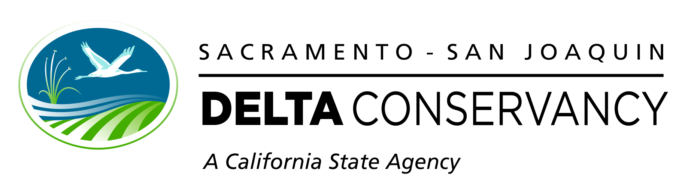

Concept Proposal Application

Cycle 5

Proposition 1

Ecosystem Restoration and Water Quality Grant Program

FUNDED BY THE
Water Quality, Supply, and Infrastructure Improvement Act of 2014
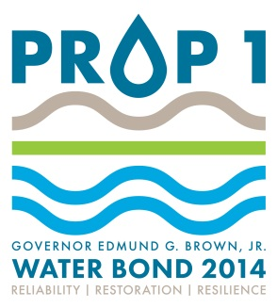

Concept Proposal Application Instructions
Concept proposals are the required first step in the Sacramento-San Joaquin Delta Conservancy’s (Delta Conservancy) two-step grant proposal process. Concept proposals should describe the project that will be submitted for consideration during the full proposal solicitation. Please read the instructions below to submit a complete, clear, and responsive concept proposal.

Concept Proposal Submission
Concept proposals must be submitted no later than 5:00pm Pacific Daylight Time (PDT) on August 31, 2021. All files must be submitted electronically via email to: prop1grants@deltaconservancy.ca.gov.

Concept Proposal Components
Complete concept proposals consist of a concept proposal application and supplementary materials. The application must not exceed fourteen pages. Applicants must use the provided text entry boxes with 12-point standard font and single line spacing. Text entry boxes are marked throughout this application with the notation: ---Click or tap here to enter text.---
Supplementary materials are not counted against the fourteen-page limit. Supplementary materials include:
- Map of project site
- Budget Table
- Performance Measures Table
The cover page, Budget Table, and Performance Measures Table templates can be found on the Delta Conservancy’s Proposition 1 Grant Program Resources webpage: http://deltaconservancy.ca.gov/proposition-1-resources/.
Budget Table instructions: Enter projected funding requests, and cost share and cost leveraging projections into the highlighted cells in the table below. All funding requests must be based on projected expenses that are eligible and must conform to the descriptions of the cost categories provided in the Grant Guidelines. Refer to the Grant Guidelines for more information on how to determine qualifying cost share and cost leveraging projections. All amounts entered in this table must match with amounts entered in all other concept proposal application documents.

Project Title
Provide a brief, descriptive project title.
Title: ---Click or tap here to enter text.---

Funding Priority
Specify all Delta Conservancy funding priorities that the project addresses (check one or more boxes).
☐ Ecosystem protection, restoration, and enhancement
☐ Water quality improvement
☐ Water-related agricultural sustainability

Project Type
Check one box.
☐ Planning
☐ Implementation

Funding Request
Total funds requested from the Delta Conservancy: $ ---Click or tap here to enter text.---

Project Duration
Start Date: (no earlier than December 2022) ---Click or tap here to enter text.---
Funding Term End Date: (no later than three years after the start date) ---Click or tap here to enter text.---

Geographic Location
Provide a general description of the project location. Include name of county, nearest city/community & address (if available).
Location: ---Click or tap here to enter text.---

Applicant Information
Applicant Name: ---Click or tap here to enter text.---
Contact Person Name: ---Click or tap here to enter text.---
Title: ---Click or tap here to enter text.---
Mailing Address: ---Click or tap here to enter text.---
Telephone: ---Click or tap here to enter text.---
Email Address: ---Click or tap here to enter text.---

Applicant Organization Type
Check one box.
☐ California Public Agency
☐ 501(c)(3) Nonprofit Organization
☐ Tribal Organization
☐ Public Utility
☐ Mutual Water Company

Concept Proposal Narrative Content
The Delta Conservancy expects concept proposals to provide a concise overview of the requested information; full details are required in the full proposal.

Project Description
Provide a clear description of the project being proposed for Delta Conservancy funding, including:
- The need for the project.
---Click or tap here to enter text.---
- The project’s goals and objectives (for implementation projects these goals and objectives must match those listed in the Performance Measures Table).
---Click or tap here to enter text.---
- General tasks that will be undertaken and work products or deliverables.
---Click or tap here to enter text.---
- For acquisition projects, the status and summary of meeting the specific requirements for acquisitions including acreage, willing seller name and address, breakdown of how the funds will be budgeted, and an acquisition schedule.
---Click or tap here to enter text.---

Project Location
Submit a map of the project site. The map should provide detail sufficient to allow a person unfamiliar with the area to locate the project, and must include a legend, scale, and polygon indicating the footprint(s) of the project, and appropriately-labeled identifying features such as roads, waterways, towns, and county boundaries. A map that meets Americans with Disabilities Act requirements is strongly encouraged.

Project Team
Describe the team’s organizational capacity, the qualifications of affiliated staff and committed partners, and any necessary partnerships that have been developed to advance the project.
---Click or tap here to enter text.---

Conflict of Interest
Identify involved parties that have conflict of interest relevant to the project. Contact Delta Conservancy staff if any member(s) of the applicant team have been formerly employed by the Delta Conservancy, presently work for the state, or have an existing agreement or previous agreement with the Delta Conservancy.
---Click or tap here to enter text.---

Budget, Cost Share, and Cost Leveraging
Provide a description that explains how budget items in the Budget Table align with project tasks described in the project description. Describe the status of cost share and cost leveraging efforts. Explain how grant management and reporting costs will be funded, either by the Delta Conservancy’s Grant Program or using cost share or state leveraged funds.
---Click or tap here to enter text.---

Alignment with State Priorities
Demonstrate that the specific, on-the-ground project is aligned with state priorities as described in:
☐ Proposition 1
Explain how the project is consistent with funding requirements, and how it benefits the public and the State of California.
---Click or tap here to enter text.---
☐ California Water Action Plan
List actions implemented and explain how this project is meeting those actions.
---Click or tap here to enter text.---
☐ Delta Conservancy’s governing statute
Explain how project links to the Delta Conservancy’s governing statute.
---Click or tap here to enter text.---
☐ Delta Conservancy’s 2017-2022 Strategic Plan
Explain how project links to and helps implement the strategic plan.
---Click or tap here to enter text.---
☐ Delta Plan
Explain how the project meets actions or recommendations of the Delta Plan.
---Click or tap here to enter text.---
☐ Other plans (e.g., existing conservation, restoration, recovery plans, or other relevant local, state, or federal plans or policies).
Identify the plan(s) and explain how the project links to the identified plans. Provide links to each plan or policy listed. Copies of the plan(s) must be available upon request.
---Click or tap here to enter text.---

Long-Term Management and Maintenance
For planning projects, describe how the planning effort will contribute to a specific, on-the-ground project. For implementation projects, describe plans for long-term management and sustainability of the project for the required minimum of 15 years.
---Click or tap here to enter text.---

Readiness
For planning projects, describe how the proposed planning activities will advance the project toward implementation, including a projected start date of the implementation project. Describe how previous and subsequent phases will ensure that environmental compliance and all data gaps are addressed. Specify whether the proposed project is beyond the feasibility stage. For implementation projects, describe the readiness to proceed with the project, indicating any work that has already been done and any additional work to be completed before beginning the work being proposed for Delta Conservancy funding. Specify when the project will be ready to begin implementation. Describe permits and landowner agreements that will be required, if applicable.
---Click or tap here to enter text.---

California Environmental Quality Act (CEQA)
Discuss the status of fulfilling any CEQA requirements, identify the CEQA lead agency, and specify whether the Delta Conservancy is the expected lead agency for CEQA and/or Delta Plan consistency.
---Click or tap here to enter text.---

Local Support
Describe local public and institutional support for the project, including how the community and stakeholders are engaged in the project. Describe the project’s approach to informing and consulting with affected parties, and to avoiding, reducing, or mitigating conflicts with existing and adjacent land uses.
---Click or tap here to enter text.---

Scientific Merit
Describe the scientific basis of the proposed project and how best available science has been or will be integrated into the project. In addition, describe how the project is applying the Delta Plan’s adaptive management framework, as appropriate to the scope of the project. Describe how the project addresses potential vulnerabilities of the project site to climate change effects, and if the project will account for and provide adaptation and/or resiliency to potential climate change effects.
---Click or tap here to enter text.---

Performance Monitoring and Assessment
For implementation projects and planning projects with an on-the-ground component, include a general description of the project’s approach to performance monitoring and assessment, and submit a Performance Measures Table using the template provided on the grant program webpage.
---Click or tap here to enter text.---

